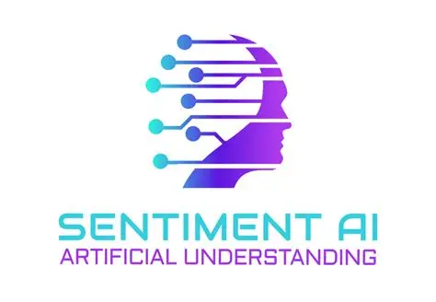

Contents

1) Introduction: 3

2) API Selection Justification: 3

3) Implementation Challenges: 3

4) User Guide Examples: 5

5) Accuracy report comparing API results to manual analysis: 14

6) Conclusion: 15

# Introduction:

In comparison to traditional human annotation, this paper provides a thorough assessment of sentiment analysis utilizing the Google Cloud Natural Language API. Sentiment analysis is essential for comprehending user sentiment and feedback in a variety of contexts, including social media, support requests, and customer evaluations. Evaluating how well machine learning models capture subjective human sentiment is crucial given the growing reliance on automation.

# API Selection Justification:

A sentiment analysis application's performance, scalability, and accuracy all depend on the API selection. Language support, usability, cost, precision, and performance are some of the variables that influence the choice.

The selected API selection is Google Cloud Natural Language API.

|  |  |  |
| --- | --- | --- |
| API: | Pros: | Cons: |
| Google Cloud Natural Language API | High accuracy, strong NLP features, multi-language support | Expensive at scale, limited customization |

Accuracy: Provides extremely accurate sentiment identification in a variety of text formats and domains.

Language Support: Essential for international content analysis, it supports several key languages.

Scalability: Suitable for production-grade applications, it effectively manages massive data volumes.

Comprehensive Analysis: Provides entity recognition, classification, syntax analysis, and sentiment analysis.

Integration is simple because to the REST API interface's comprehensive documentation and multiple SDKs.

Considerations:

Because of the cost per request, budget preparation could be necessary. Sensitive content supplied to cloud APIs must take data privacy into account.

# Implementation Challenges:

1. Text cleaning and preprocessing:

Problem: Emojis, hashtags, links, slang, and mistakes are all present in raw text data, such as that found on social media.

Solution: Put in place reliable preparation pipelines that include normalization, stop word removal, tokenization, and, if necessary, emoji translation.

1. Managing Data in Multiple Languages:

Challenge: Some APIs have limited support, and sentiment nuances differ between languages.

Solution: Direct text to the proper pipelines or APIs by using language detection tools (such as lang detect).

1. Identifying Personality and Humour:

Challenge: Standard models frequently incorrectly classify statements that are unclear or critical.

Solution: If necessary, train bespoke ML models or provide contextual metadata (such as emojis or user behaviour).

1. Rate Limits for APIs and Cost Control:

Challenge: Many inquiries may result in expenses or exceed rate caps.

Solution: To maximize use, employ batching, parallel processing, and caching of frequently asked queries.

1. Interpretability:

Problem: Although the API provides sentiment scores, stakeholders would want an explanation or practical insights.

Solution: Sort scores into three categories (positive, neutral, and negative) and, if available, give word-level sentiment or sample highlights.

1. Connectivity with Current Systems:

Challenge: Standardization is necessary when integrating API answers with UI or business logic solutions.

The answer is to define a uniform internal schema and, for flexibility, wrap API calls in service layers.

# User Guide Examples:

This guide provides explanations for the key outputs generated by a sentiment analysis system, helping users understand and interpret results more effectively.

1. Text analysis:

What it is:

Examining a body of text to glean important details like its personal nature, emotional tone, and main topics is known as text analysis.

How sentiment analysis operates:

The input text, whether it be a sentence, paragraph, or document, is divided into syntactic and semantic components by the system. Techniques from Natural Language Processing (NLP) are used in:

Tokenize terms and expressions

Parse sentence construction

Named entities (people, goods, and places) should be identified.

Find grammatical connections

This prepares the reader for a more in-depth interpretation of sentiment.

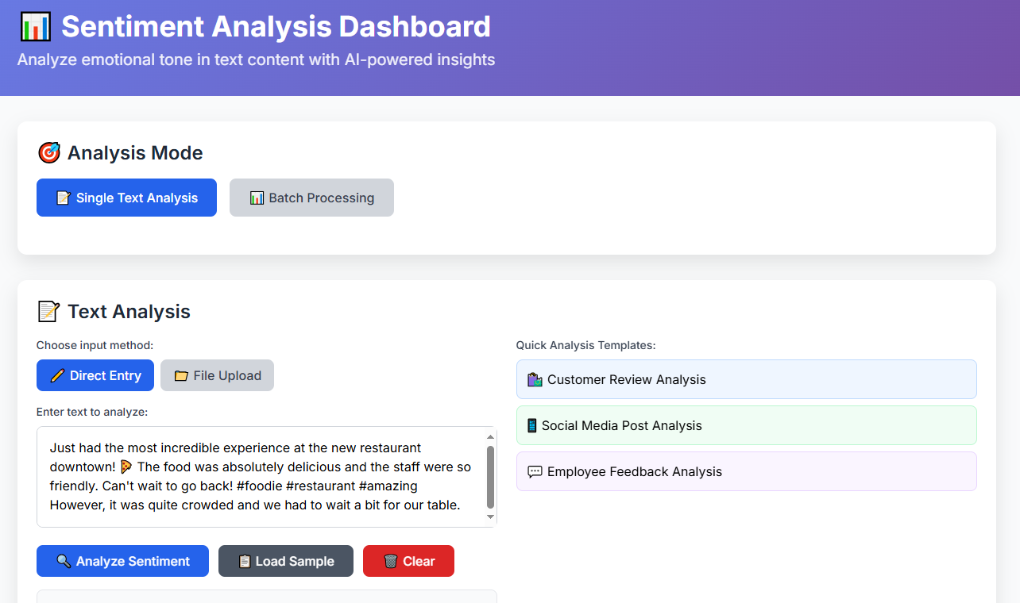

1. Overall Sentiment:

What it is:

The overall emotional tone found throughout the text is known as overall sentiment. Usually, it is divided into three groups:

Positive - The tone of the writing is upbeat or positive.

Neutral: The writing is impartial or devoid of strong feelings.

Negative: The text conveys discontent, criticism, or worry.

For instance:

Text: "The customer service was awful, but the product is fine."

Overall Attitude: Negative (since "terrible" has a greater emotional burden)

1. Confidence Score Explanation:

What Is It?

The model's level of certainty on the mood classification is shown by its confidence score. Usually, it is expressed as a decimal or percentage (for example, 0.87 or 87%).

|  |  |
| --- | --- |
| Confidence Score: | Interpretation: |
| 90-100% | Very High Confidence |
| 70-89% | High Confidence |
| 50-69% | Moderate Confidence |
| Below 50% | Low Confidence |

1. Sentiment Driver Analysis:

What are they?

Certain words or phrases in the text that affect the overall sentiment classification are known as sentiment drivers. Comprehending these aids in determining the rationale behind a text's classification.

Essential Elements of Emotion Analysis of Drivers:

Driver words are emotional keywords (such as "outstanding" or "terrible").

Alternators: words like "very" and "slightly" that amplify or soften feelings.

Context: Language specific to a domain or sentence structure that influences sentiment.

Analysis Example:

Text: "Delivery was slow, but the product quality is excellent."

Emotion: Indifferent/Neutral

Drivers:

Positive: "excellent" (provokes feelings of positivity)

Bad: "slow delivery" (causes unfavorable feelings)

Prioritizing the aspects of the experience that require attention is made easier with driver analysis.

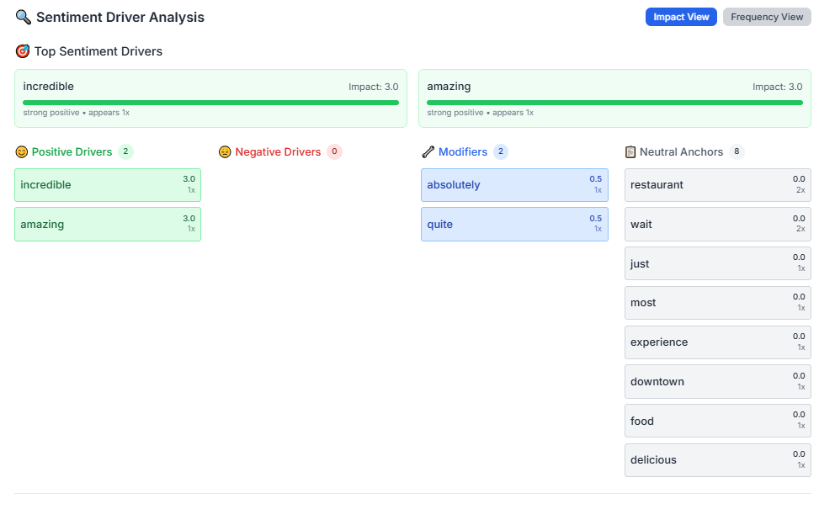

1. Text with Sentiment Highlighting:

Interpretability is enhanced by underlining sentimental words in the text, particularly in reviews, social media posts, and customer testimonials.

Convention for Colour Coding:

Good Feelings—Green Highlight

Red highlights indicate a negative sentiment.

Neutral/Objective: No highlight or yellow

Benefits:

Sentiment drivers shown visually

Finding positive and negative feedback areas quickly

Beneficial for customer experience and user experience analysis

Last Words:

Sentiment analysis uses cases include:

Analysis of customer feedback

Monitoring brand reputation and compiling product reviews

Surveys of employee satisfaction

Sentiment analysis on social media

Limitations: It can be difficult to recognize irony and sarcasm.

Custom training may be necessary for domain-specific terminology; ambiguity in language can reduce accuracy.

Increasing Outcomes: Apply domain-specific models

Integrate topic modelling with sentiment

Train continuously using updated datasets.

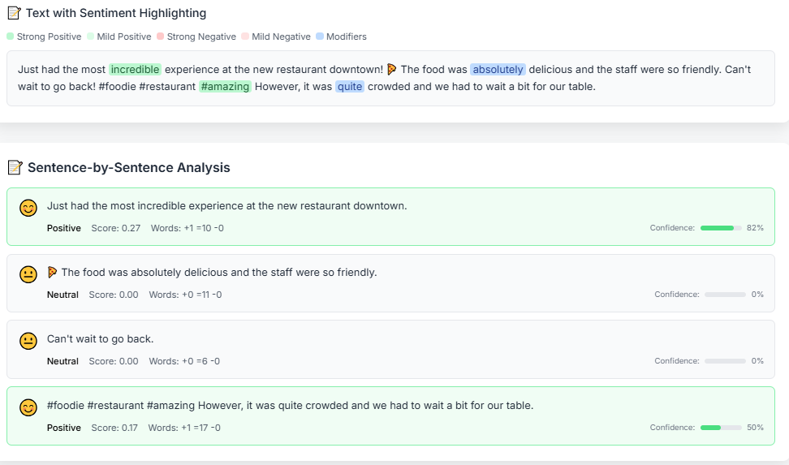

# Accuracy report comparing API results to manual analysis:

Limitations of the Google Cloud Natural Language API:

A powerful pre-trained sentiment analysis service offered by the Google Cloud Natural Language API can swiftly categorize text as neutral, negative, or positive. When contrasting its outcomes with manual analysis, it is important to consider several limitations:

1. Contextual Knowledge: Some phrases may be difficult for the API to understand in terms of context or intent. For example, subtle irony or sarcasm frequently goes unnoticed. Due to literal word usage, the API might interpret "Great" as a positive feeling whereas a human reviewer would rightly describe it as negative.
2. Managing Contradictory Feelings:

Mixed feelings can be found in many real-world writings (e.g., “The app keeps crashing, but the design is beautiful”). Due to the tendency to assign a general sentiment, the API may overlook feedback that is dual-aspect or nuanced. When it comes to recognizing and distinguishing between several sentiment drivers in a single text, manual labelling is more accurate.

1. Language Specific to a Domain:

General datasets are used to train the API. Domain-specific language might not be correctly understood in specialist fields like technical support, healthcare, or finance. For instance, the API may interpret "performance" as positive even when " unpredictable performance" is negative in a financial context.

1. Insecurity and Confidence:

Although a confidence score is frequently provided by the API, low or borderline scores (such as 50–60%) indicate some degree of ambiguity. Human evaluation is necessary in these circumstances. Furthermore, ambiguous or brief texts that people might interpret differently depending on tone or meanings may result in the API returning "neutral" more frequently.

1. Sensitivity to Language and Grammar:

The API is sensitive to grammatical, spelling, and cultural errors. Inaccurate classifications may result from misspelled words or colloquialisms. Slang terms that are used favourably, such as "that's sick!" could be misclassified.

1. Absence of explanation or transparency

The predictions made by the API are not transparently explained. The API provides a classification without providing information about the words or phrases that influenced the outcome, in contrast to human reviewers who can defend their choices based on context or emotional cues.

# Conclusion:

According to the investigation, the Google Cloud Natural Language API has significant limits in detecting complicated, mixed, or domain-specific attitudes, even though it performs well in general sentiment categorization, especially for statements that are obviously positive or negative. Although the API attains a reasonable degree of accuracy, it is still unable to comprehend complicated or confusing texts at the human level.